**DAILY ASSESSMENT REPORT**

|  |  |  |  |
| --- | --- | --- | --- |
| **Date:** | **13 June 2020** | **Name:** | **Manavi** |
| **Course:** | **PCB** | **USN:** | **4AL18EC031** |
| **GitHub Repository:** | **Manavi-test** | **Semester & Section:** | **4th Sem ‘A’ Sec** |

**FORENOON SESSION**

**Image of the session**

* **PCB**
* **Add Footprint search path**
* **A footprint or land pattern is the arrangement of pads (in surface-mount technology) or through-holes (in through-hole technology) used to physically attach and electrically connect a component to a printed circuit board**
* **The land pattern on a circuit board matches the arrangement of leads on a component**
* **Prepare production files**

**AFTERNOON SESSION**

|  |  |  |  |
| --- | --- | --- | --- |
| **Date:** | **13 june 2020** | **Name:** | **Manavi** |
| **Course:** | **JAVA** | **USN:** | **4AL18EC031** |
| **GitHub Repository:** | **Manavi-test** | **Semester & Section:** | **4th Sem ‘A’ Sec** |

**Image of the session**

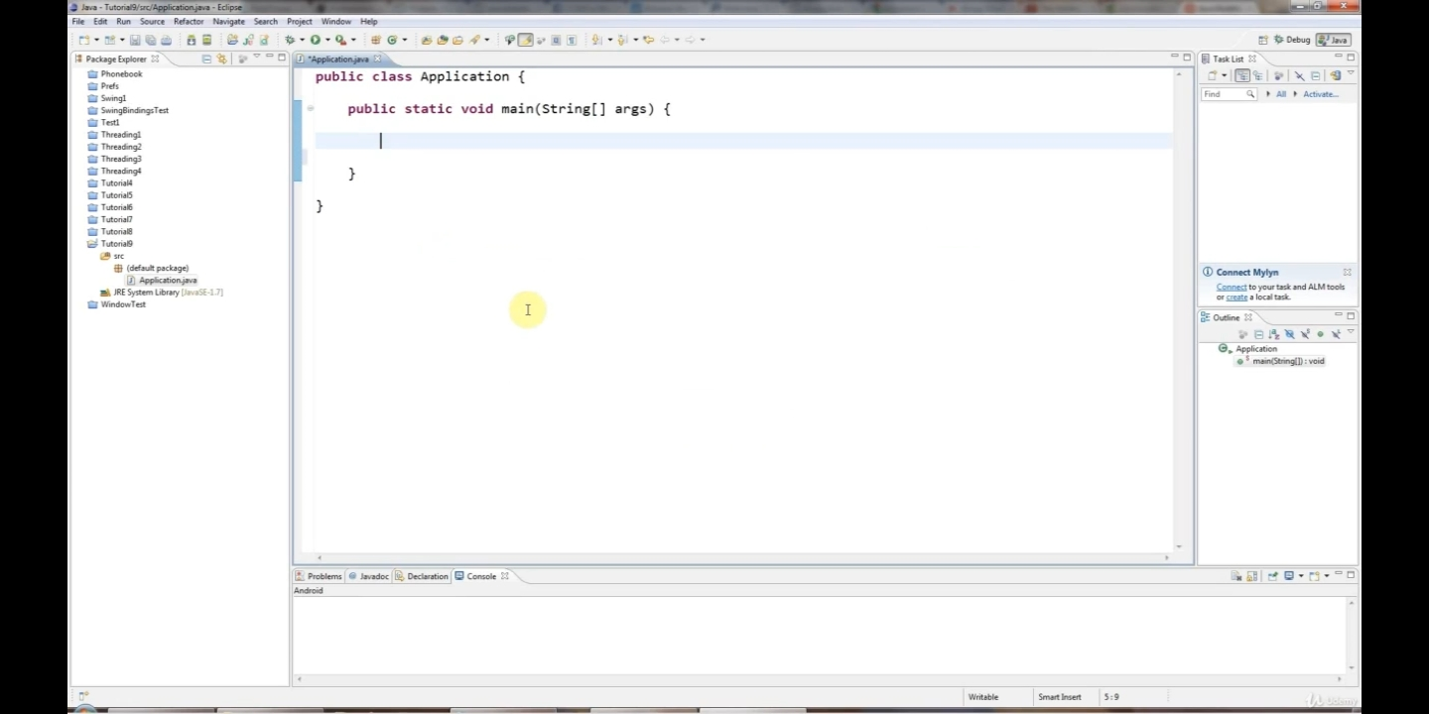

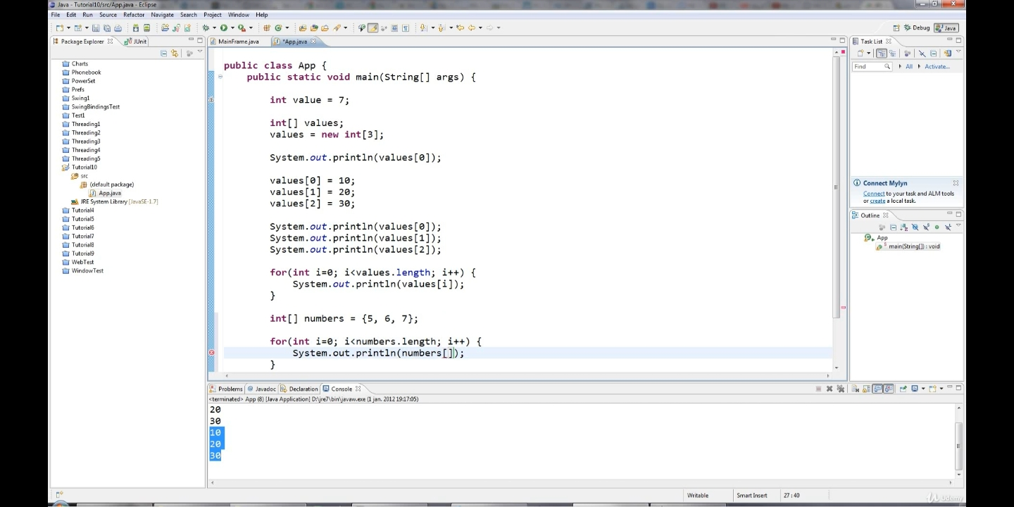

**Report:-**

**Genetics and wildcards.**

**Anonymous classes.**

**Reading files using scanner.**

**Handling exceptions.**

**Multiple exceptions.**